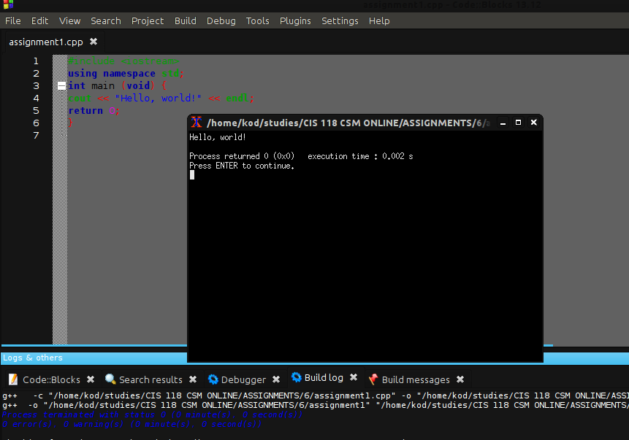

John Ballard CIS 118 6.24.15
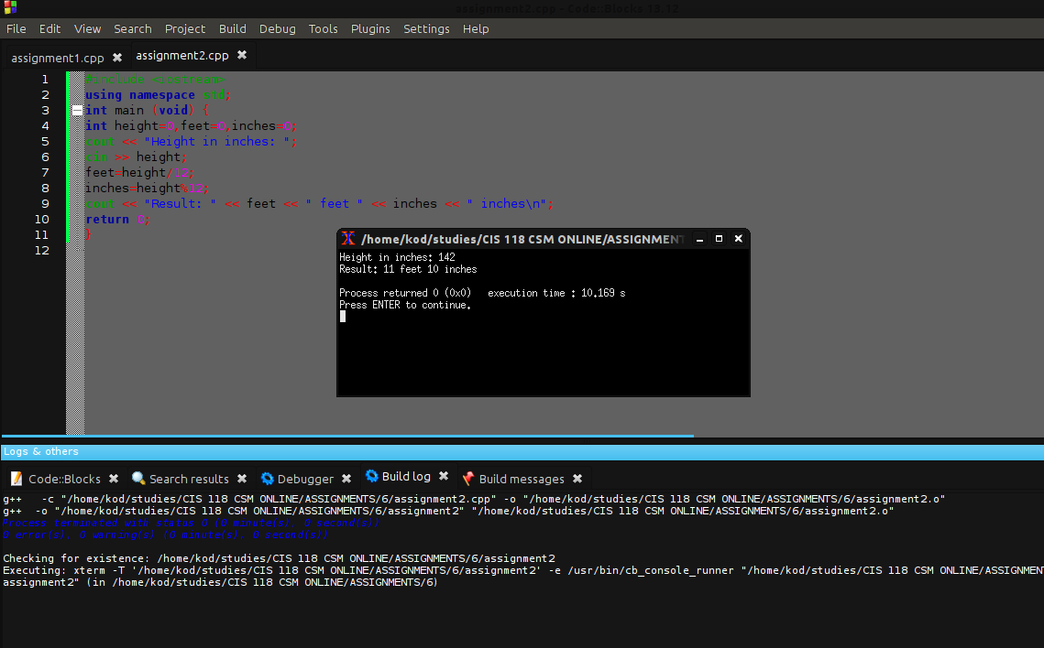

Didn't have any issues, I learned to always double check my spelling though.

